Lawyering Skills & Strategies I
Fall 2026
INSTRUCTIONS FOR DRAFTING THE FINAL MEMORANDUM (THE “OPEN MEMORANDUM” OR “OPEN MEMO”)

1. This assignment is subject to the University of Houston Honor Code. You may not discuss or show your work to any other law students, persons outside the Law Center, or other professors. You may, however, consult the Legal Writing Center, Law Librarians, or the Research Fellows for generic assistance on research and writing (such as research strategy, sentence and paragraph structure, grammar, punctuation, and citation format), but not for specific questions regarding this Open Memo assignment. You should come directly to me if you have any questions about specific questions regarding the Open Memo.
2. This is an anonymous assignment. Do not put your name or other personally identifying information anywhere in your final memorandum or in the file name that you upload to Canvas. Instead, use your Fall Midterm Number in the “From” line of the memo.
3. For this assignment, you will be drafting a complete legal research memorandum. Your memorandum should include each of the following sections: Questions Presented, Brief Answers, Statement of Facts, Discussion, Conclusion. As we will discuss in class and you will see on the Template, I encourage you to use headings to divide up the different issues and subissues in your analysis.
4. Follow the directions as to substance of the legal issue in the partner memo, and do not address any other issues.
5. Use proper Bluebook format for all citations.
6. You can and should use Grammarly or Editor in Microsoft Word to check for grammar and stylistic errors (e.g., sentences in passive voice). You may also use the Lexis or Westlaw versions of AI for research purposes. You are allowed to use AI for anything
7. All formatting for this assignment, including the spacing, type style, font size, margins, page numbering, etc., must comply with my the following:
- Submitted electronically as Microsoft Word documents in .doc or .docx format.
- Times New Roman, 12-point type on white letter-size paper.
- Double space each page.
- One-inch margins on all sides.
- Place page numbers in the bottom center of each page.
Issue one of the Discussion should start on the top of a page and be no longer than four pages total. Issue two of the Discussion should also start at the top of a page and be no longer than five pages total. Those are the only length requirements for the memo. Otherwise, the memo sections should be of a reasonable length to support your Discussion. I am providing a template on Canvas that you should follow for formatting.
8. You must turn in an electronic copy of this assignment via Canvas by Sunday, November 8, 2026, at 5:00 p.m. If your submission is turned in after the deadline, it will be considered late, and penalties will apply.
Good luck!
Open Memorandum Assignment

TO: Associate
FROM: Lizbeth Casco, Partner
DATE: October 12, 2026
RE: Fox v. Aperture Forensics, Inc., jurisdictional and merits assessment
Unfortunately, we lost our motion to remand, and the case is proceeding in federal court. Discovery has now closed. Before I decide how to proceed, I need you to draft a memo on two issues: 1) an analysis of Fox’s domicile for diversity purposes, and 2) whether the malicious prosecution claim we have asserted on Fox’s behalf is likely to succeed.
For the first issue, include a revised version of your written analysis of Fox’s domicile. Do not do any additional research on this issue. We just want to preserve a revised version of your earlier analysis for the file.
For the second issue, you will be analyzing the merits of Fox’s malicious prosecution claim under Tennessee law against Aperture Forensics, a company responsible for him being arrested based on an inaccurate facial recognition identification. Evaluate the claim on the record developed in discovery and determine our likelihood of success. Your analysis will help us decide how aggressively to approach settlement discussions.
From my preliminary research, under Tennessee law, the tort of malicious prosecution has four elements:
1. Institution or procurement of a prior legal action.
2. Want of probable cause.
3. Malice.
4. Favorable termination.

You may address and dismiss elements 1 and 4 quickly in your rules, as I am satisfied that Aperture instituted or procured the prosecution by giving the police false information and that there was a favorable termination as seen in the Order of Dismissal. Spend your time on the second and third elements as that is where the key dispute will likely be. (Something to note: Tennessee courts sometimes describe the tort of malicious prosecution as having three elements instead of four, depending on whether the institution and probable cause requirements are stated together or separately. You should organize your analysis around a four-element test.)
You may rely on unpublished Tennessee opinions as well as published ones. If you cite an unpublished opinion, identify it as unpublished and treat it as persuasive rather than binding authority.
You also should assume the analyst in this case acted within the course and scope of his employment at all relevant times, thus making Aperture accountable for his actions. Do not analyze vicarious liability, negligent hiring or supervision, defamation, negligence, any civil rights claim, or damages. Aperture is the only Defendant in this case; there is no case pending or contemplated against the Nashville Police Department, individual officers, or Marlowe’s. Another associate is analyzing the possible false imprisonment theory.
We will be meeting with Fox in mid-November to update him on the status of the case and to discuss whether to pursue settlement, so please get me this memo by November 8, so we will be well prepared to advise him.
Our Complaint follows, along with Aperture’s verified responses to our interrogatories, and excerpts from the depositions of Marcus Donovan, Richard Simpson, and Detective Owen Blair. The exhibits marked at each deposition are attached after that deposition’s transcript.

IN THE CIRCUIT COURT FOR DAVIDSON COUNTY, TENNESSEE
AT NASHVILLE

JALEN T. FOX,
Plaintiff,
v. No. 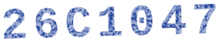
APERTURE FORENSICS, INC.,
Defendant.
JURY DEMANDED
COMPLAINT FOR MALICIOUS PROSECUTION AND FALSE IMPRISONMENT
Plaintiff Jalen T. Fox, by and through counsel, for his Complaint against Defendant Aperture Forensics, Inc., alleges as follows:
PRELIMINARY STATEMENT
1. Defendant Aperture Forensics, Inc. (“Aperture”), a seller of facial recognition services to retailers, falsely identified Plaintiff Jalen T. Fox to the police as the perpetrator of a theft at a local store, resulting in his arrest and detention. Mr. Fox, a Black musician in his twenties, did not commit the theft. He was at a rehearsal with roughly thirty other people when it happened. The charge was dismissed because of his innocence, but not before Mr. Fox lost work opportunities and suffered mental harm from spending a weekend in jail on a charge supported by nothing other than a facial recognition misidentification.
2. Facial recognition is a technology with well-known limits, and Aperture did not respect them. Facial recognition is widely recognized to return false matches more often for Black individuals than for others. Wrongful arrests of Black men based on facial recognition misidentifications have been documented across the country. Additionally, the images used to implicate Mr. Fox were low quality, and it is well known that an image taken from a distance, or one in which the face is obscured, makes identification less reliable. Aperture, whose business is facial recognition, knows these limits. Yet its signed report and its statements identifying Mr. Fox to the police disclosed none of them. Aperture knowingly overstated its verification process and reliability, which resulted in the harm experience by Mr. Fox. Mr. Fox brings this action for malicious prosecution and false imprisonment under Tennessee law.
PARTIES
3. Plaintiff Jalen T. Fox is an individual who resides at 118 Shelby Avenue, Apartment 3B, Nashville, Tennessee 37206.
4. Defendant Aperture is incorporated in Tennessee and has its principal place of business in Nashville. It sells facial recognition services to retail customers across the Southeast.
JURISDICTION AND VENUE
5. This Court has subject matter jurisdiction over this action, which arises under Tennessee common law.
6. Venue is proper in Davidson County because the events giving rise to this action occurred in Davidson County and Aperture maintains its principal place of business there.
FACTUAL ALLEGATIONS
A. The Theft
7. On Thursday, March 5, 2026, at about 2:40 p.m., someone stole roughly $4,300 in merchandise from the Marlowe’s Department Stores, Inc. (“Marlowe’s”) store in Green Hills, Tennessee.
8. A single store camera recorded the alleged thief.

B. Fox’s Location during the Theft
9. Mr. Fox was not at Marlowe’s during the theft. From 1:10 p.m. through 6:05 p.m. on March 5, 2026, he was at Hartwell Rehearsal Co. (“Hartwell”) on Bransford Avenue, where roughly thirty people saw him and where a security camera recorded him entering and leaving. The entire time Fox was at Hartwell, he was with colleagues. That afternoon, he also posted to a public social media account a photograph from the rehearsal.
10. Hartwell is a fifteen-minute drive each way to the Marlowe’s in Green Hills. As Mr. Fox was never alone and it would be a thirty-minute round trip to Marlowe’s, he could not have been the person captured by video surveillance.
C. Aperture’s “Positive Identification”
11. Marlowe’s is a customer of Aperture. Aperture provides its customers with facial recognition services whenever a customer provides security footage, and Aperture also coordinates with law enforcement.
12. Marlowe’s gave Aperture four still frames from the store camera and asked Aperture to identify the person in them. The frames were taken by a ceiling camera from roughly twenty feet away, and in three of the four a hood partly shadows the person’s face.
13. On March 6, 2026, Richard A. Simpson, an analyst in Aperture’s Identification Services Division, issued Subject Identification Report No. AF-2026-0311 (the “Report”), naming Mr. Fox as the person in the store images.
14. The Report, which Simpson signed, states that Simpson compared Mr. Fox’s Tennessee driver’s license photograph to the store images and found that “[f]acial geometry, hairline, jaw structure, and build are consistent across probe and reference images.” It certifies that the identification “reflects my professional judgment as a certified identification analyst.” Under the heading “Corroboration obtained,” it lists one item: “Store management visual confirmation.”
15. The Report does not say how Mr. Fox came to Aperture’s attention, does not disclose that facial recognition software was involved, and does not state how confident any match was. Mr. Fox is informed and believes that Aperture arrived at him by running the store images through its facial recognition system against a database of driver’s license photographs, and that a software match, not an investigation, is why Aperture looked at him at all.
16. Mr. Fox is informed and believes that no one who saw the theft identified him, and that the “store management visual confirmation” was not a positive identification of Mr. Fox by anyone who saw it.
C. Aperture Goes to the Police
17. Mr. Fox is informed and believes that, on March 6, 2026, Simpson communicated with Detective Owen Blair of the Metropolitan Nashville Police Department and told him that Aperture had made a “positive identification” of Mr. Fox and that store management had confirmed it, despite knowing the limitations of the systems and failing to properly investigate. Aperture also gave Blair the Report, which lists Mr. Fox’s name, address, and vehicle.
18. That evening, Blair swore an Affidavit of Complaint charging Mr. Fox with felony theft of property. The Affidavit recites that “affiant spoke with a certified identification analyst, who has positively identified the subject depicted in store surveillance imagery as Jalen Fox,” and that “the identification has been confirmed by store management.” It attaches the Report.
19. The Affidavit does not say that the identification began with facial recognition software, and it does not describe any limits on how reliable such software is. It identifies no evidence connecting Mr. Fox to the theft other than Aperture’s identification and the store’s purported confirmation. Mr. Fox is informed and believes that Blair swore the Affidavit, and caused Mr. Fox to be arrested, in reliance on what Aperture told him and on the Report.
D. Mr. Fox Is Arrested and Jailed
20. At approximately 9:20 p.m. on Friday, March 6, 2026, patrol officers arrested Mr. Fox outside his apartment building as he returned from a gig. He had no criminal record. He was booked into the Davidson County jail and held through the weekend.
21. Mr. Fox told the jail staff repeatedly that he had been at a rehearsal when the theft occurred, that roughly thirty people had seen him there, and that he had posted a photograph from the rehearsal online that afternoon. No one followed up.
22. Mr. Fox was distraught and feared for his personal safety, as he was kept in a bare cell with ten other men. For the duration of his time in jail, he could not sleep.
23. Mr. Fox was arraigned on Monday, March 9, and released on bond after roughly sixty-two hours in custody.
E. The Charge Is Dismissed
24. On March 20, 2026, the State filed an information charging Mr. Fox with felony theft of property over $2,500. No indictment was sought, and no grand jury proceeding occurred.
25. On April 14, 2026, on the State’s motion, the Criminal Court dismissed the charge with prejudice. The order of dismissal states that timestamped security video maintained by Hartwell places Mr. Fox at the rehearsal space continuously from 1:10 p.m. through 6:05 p.m. on March 5, 2026, and therefore excludes him as the perpetrator.
F. The Arrest’s Impact on Mr. Fox
26. Because he was in jail, Mr. Fox missed a paid musical performance on Saturday, March 7, for a $600 fee. The same venue had offered him a recurring Sunday residency and withdrew the offer after a local music blog reported his arrest.
27. Mr. Fox paid a bondsman $1,000 to be released and $2,500 to retain criminal defense counsel. He has difficulty sleeping and has stopped accepting bookings near the Green Hills store.
COUNT I
MALICIOUS PROSECUTION
28. Mr. Fox incorporates the preceding paragraphs as if fully set forth here.
29. Aperture instituted or procured the criminal proceeding against Mr. Fox by identifying him to Detective Blair as the thief and supplying the Report on which Blair relied to swear the affidavit of complaint.
30. Aperture did so without probable cause. Mr. Fox did not commit the theft, and Aperture had no reasonable ground to believe that he did.
31. Aperture did so with malice. Aperture’s positive identification of Mr. Fox was knowingly false because it knew of the limitations of facial recognition and overstated the verification received.
32. The criminal proceeding terminated in Mr. Fox’s favor when the Criminal Court dismissed the charge with prejudice on April 14, 2026.
33. As a direct and proximate result of Aperture’s conduct, Mr. Fox suffered damages, including loss of liberty, bond and attorney’s fees, lost income and professional opportunities, harm to his reputation, and emotional distress.
COUNT II
FALSE IMPRISONMENT
34. Mr. Fox incorporates the preceding paragraphs as if fully set forth here.
35. Mr. Fox was restrained against his will from his arrest on the night of March 6, 2026, until his release on bond on March 9, 2026.
36. The restraint was unlawful because there was no probable cause to arrest or hold him.
37. Aperture caused the restraint. It did not simply pass along a suspicion; it presented its identification of Mr. Fox as a certainty, knowing the police would act on it.
38. As a direct and proximate result of Aperture’s conduct, Mr. Fox lost his liberty and suffered the damages described above.
PRAYER FOR RELIEF
WHEREFORE, Plaintiff respectfully requests that the Court:
1. Award Plaintiff compensatory damages on Counts I and II in the amount of $250,000;
2. Tax the costs of this action to Defendant;
3. Empanel a jury to try all issues so triable; and
4. Grant such other and further relief as the Court deems just.

Respectfully submitted, May 15, 2026
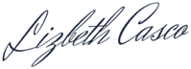
Lizbeth Casco
Counsel for Plaintiff Jalen T. Fox

IN THE UNITED STATES DISTRICT COURT
FOR THE MIDDLE DISTRICT OF TENNESSEE
NASHVILLE DIVISION
JALEN T. FOX,  Plaintiff,  v.  APERTURE FORENSICS, INC.,  Defendant. | Case No. 26-cv-10827  JURY DEMAND

DEFENDANT APERTURE FORENSICS, INC.’S RESPONSES
TO PLAINTIFF’S FIRST SET OF INTERROGATORIES
Under Rules 26 and 33 of the Federal Rules of Civil Procedure, Defendant Aperture Forensics, Inc. (“Aperture”) responds as follows to Plaintiff Jalen T. Fox’s First Set of Interrogatories. These answers are based on information now reasonably available to Aperture, which will supplement them as Rule 26(e) requires. Documents cited by Bates number are being produced with these responses.
INTERROGATORY NO. 1: Describe the identification service Aperture provides to retail clients such as Marlowe’s, including what the client provides, what Aperture’s system produces, and who at Aperture reviews the result.
ANSWER: Aperture objects to the phrase “identification service” as vague, and to this Interrogatory as overbroad to the extent it seeks a description of Aperture’s proprietary algorithms. Subject to those objections, Aperture answers at a general level.
Aperture does not license software to its retail clients. Under its Retail Security Agreements, a client uploads surveillance imagery to Aperture, and Aperture’s algorithmic system generates a ranked candidate list. Aperture’s Identification Services Division then assigns a staff analyst, who reviews the candidate list, reviews the imagery, follows up to gather additional verification of the lead from the client, and, if satisfied, issues a signed Subject Identification Report to the client. It will also interface with law enforcement where appropriate.
INTERROGATORY NO. 2: Identify the agreement under which Aperture provided services to Marlowe’s in March 2026, and state its term and its provisions concerning analyst judgment and coordination with law enforcement.
ANSWER: Aperture objects to this Interrogatory because the Agreement speaks for itself, and to the extent it asks Aperture to characterize contract provisions, which calls for a legal conclusion. Subject to those objections, Aperture answers by quoting the Agreement.
Aperture provided services to Marlowe’s under Retail Security Agreement No. RSA-2023-0914 (the “Agreement”). The Agreement’s term ran from April 1, 2023 to March 31, 2026. Section 1.2 provides that the client “acknowledges that Aperture’s services include the professional judgment of a certified identification analyst and are not limited to the output of automated comparison.” Section 1.4 provides that, at no additional charge, Aperture analysts “are available to coordinate directly with responding law enforcement agencies.”
INTERROGATORY NO. 3: Describe the contract renewal process between Marlowe’s and Aperture in March 2026 and the pressure on analysts to make identifications for Marlowe’s.
ANSWER: Aperture objects to this Interrogatory because it seeks confidential negotiation information and mischaracterizes the working relationship between Aperture’s analysts and Marlowe’s. Subject to those objections, Aperture answers as follows.
Marlowe’s first three-year contract with Aperture was set to expire on March 31, 2026, and Aperture was negotiating a renewal of that contract during the Spring of 2026. Aperture was notified by Marlowe’s that they were considering other options for their security needs. Aperture denies that there was pressure put on analysts to return positive identifications.
INTERROGATORY NO. 4: Describe how Aperture’s identification analysts’ bonuses were calculated in 2026.
ANSWER: Aperture objects to this Interrogatory because it seeks confidential compensation information and, as to analysts other than Mr. Simpson, is not relevant to any claim or defense or proportional to the needs of the case. Subject to those objections, and under the parties’ protective order, Aperture answers as follows.
Under Aperture’s 2026 bonus schedule, analyst bonuses are calculated in part on confirmed identifications. An analyst receives $150 for each identification that results in a criminal charge, up to $3,000 per quarter. The bonus is not reduced or reversed if the identification later turns out to be incorrect. Aperture denies that the schedule was intended to reward inaccurate identifications; Aperture does not adjust for later corrections because it generally has no reliable visibility into how a client or law enforcement agency resolves a matter.
VERIFICATION
I, Thomas Reiner, am Aperture Forensics, Inc.’s Director of Identification Services and am authorized to make this verification on its behalf. I have read the foregoing answers to Plaintiff’s First Set of Interrogatories. The answers are based on my personal knowledge and on information assembled from Aperture’s records and employees. Under 28 U.S.C. § 1746, I declare under penalty of perjury that the foregoing answers are true and correct.
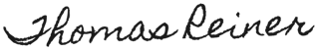
Executed on August 12, 2026.
Thomas Reiner
Director of Identification Services, Aperture Forensics, Inc.
DEPOSITION OF RICHARD A. SIMPSON (EXCERPTS)
Fox v. Aperture Forensics, Inc. (M.D. Tenn.) · Taken September 15, 2026
Q. When did you start at Aperture?
A. February 2022. I’m a senior identification analyst in the Identification Services Division.
Q. Did you complete Aperture’s annual analyst training in in 2026?A. Yes. I finished it on January 16, 2026.
Q. What was included in the training?
A. There were five modules that covered probe image assessment, similarity scoring and confidence bands, accuracy limitations and demographic performance, Identification Protocol IP-6, and report drafting and law enforcement contact.
Q. Did you sign an acknowledgment when you finished that you understood that a similarity score is not an identification?
A. Yes.
Q. Did you acknowledge that scores below 90.0 fall outside Aperture’s high confidence band, that false-match rates vary materially across subject groups, and that no Subject Identification Report may issue without corroboration satisfying IP-6?
A. Yes. That’s the standard acknowledgment. I signed it.
Q. How many Subject Identification Reports have you issued at Aperture?
A. About 300.
Q. How many of those were later shown to name a different person?
A. Four that I know of.
Q. Have you ever been disciplined?
A. No.
Q. Before this request, how had your Marlowe’s requests in 2026 come out?
A. I had three in January and February. All three closed inconclusive.
Q. Does an inconclusive result count toward your bonus?
A. No. Only identifications count.
Q. How is your quarterly bonus calculated?
A. Part of it is based on confirmed identifications. Under the 2026 schedule, I get $150 for each identification that results in a criminal charge, up to $3,000 a quarter.
Q. Did you receive a bonus for your identification of Mr. Fox?
A. Yes. He was charged, so it counted.
Q. Was that bonus taken back when the charge against Mr. Fox was dismissed?
A. No. Nothing in the schedule says it comes back.
Q. Did you know about the bonus schedule when you issued your report on Mr. Fox?
A. Of course. Everyone on the team knows it.
(Deposition Exhibit 1 was marked for identification.)
Q. I’m handing you what has been marked as Deposition Exhibit 1. Do you recognize it?
A. Yes. That’s the candidate list our system generated on the Marlowe’s request.
Q. Is it a true and accurate copy of the screen as it appeared to you on March 6?
A. Yes.
Q. Who was ranked first, and with what score?
A. Fox, at 87.2.
(Deposition Exhibit 2 was marked for identification.)
Q. Now I’m handing you Deposition Exhibit 2. Do you recognize it?
A. Yes. That’s the Accuracy Limitations page. It’s linked from the candidate list screen.
Q. Had you reviewed it before March 6, 2026?
A. Yes. It was part of my training.
Q. Under Exhibit 2, what band does a score of 87.2 fall in?
A. Moderate.
Q. And “moderate” ranking means there is an elevated risk of misidentification, correct?
A. Yes.
Q. Mr. Fox is Black. Did you treat his identification any differently in light of the system limitations around identifying Black individuals?
A. No. I am always rigorous in my process, so I did not see a need to go beyond it.
(Deposition Exhibit 3 was marked for identification.)
Q. Deposition Exhibit 3. Do you recognize it?
A. Yes. That’s IP-6, our corroboration protocol, I reviewed it in my annual training.
Q. Is that the version that was in effect on March 6, 2026?
A. Yes.
Q. Do you know what comparison image the Aperture system used to identify Jalen Fox as a candidate?
A. I believe it was his Tennessee driver’s license.
Q. Did you believe the man in the probe imagery was Mr. Fox?
A. I believed it, and I still believe the man in the imagery resembled Fox. My visual comparison was careful. I would have reached the same conclusion without the system.
(Deposition Exhibit 4 was marked for identification.)
Q. I’m handing you Deposition Exhibit 4. Do you recognize it?
A. Yes. That’s my Subject Identification Report, AF-2026-0311. That’s my signature on it.
Q. Why did your report say “positive identification” when the candidate screen said the opposite?
A. That’s how we talk about it internally. A positive ID means the analyst has signed off. It doesn’t mean the computer said so. It means I did.
Q. Why didn’t you record the similarity score in Exhibit 4?
A. The report form doesn’t have a field for it. We don’t put scores in client reports. Clients aren’t trained to read them, and they’d misuse them.
Q. The report says “store management visual confirmation.” What was that based on?
A. I emailed the store for corroboration after I got the match with Fox.
(Deposition Exhibit 5 was marked for identification.)
Q. I’m handing you what has been marked as Deposition Exhibit 5. Do you recognize these emails?
A. Yes, except Karen Diaz’s February email to Tom Reiner. I hadn’t seen that until this case.
Q. Direct your attention to the March 2 email from Mr. Reiner. How did you interpret this email?
A. Everybody gets emails like that. It didn’t change what I saw in the photographs.
Q. Turn to your forwarded conversation in your 3:40 p.m. email. Why did you email Mr. Donovan?
A. He was the store manager on duty. I wanted someone at the store to look at the photo.
Q. Is Mr. Donovan’s 2:47 p.m. reply the basis for the corroboration entry in your report?
A. Yes. Donovan said it could be him. I wrote “store management visual confirmation” in my report. I’d say that’s accurate. Maybe I’d word it differently now.
Q. Did you obtain a second means of corroboration under IP-6?
A. Not formally, no. In practice nobody gets two on a case like this. If we held every report to two, we’d never make a positive suspect identification.
Q. Did you take any other step to corroborate the identification like requesting his vehicle records or his transaction history at Marlowe’s?
A. No.
Q. In your 3:40 p.m. email on March 6, what did you mean by “this one should help”?
A. That the account needed a closed file and here was one. I knew the renewal was coming.
Q. What did you do after getting Reiner’s response?
A. I issued the signed report and called Detective Blair.
Q. Was the call recorded?
A. No.
Q. Did you send Detective Blair anything?
A. After the call, I sent him the signed report.
Q. This is the same report that said there was a visual confirmation by store management?
A. Yes.
Q. Did you tell Detective Blair the identification came from software?
A. I’m fairly sure I said it came through our system. That’s my normal practice. I can’t tell you his exact words back.
Q. What did you mean when you told Detective Blair he shouldn’t need to go further?
A. I meant he didn’t need to wait on us for anything more. We were done on our end. I wasn’t telling a detective how to run his case.
DEPOSITION EXHIBIT 1
Simpson 9/15/26
Candidate list, Service Request AF-2026-0311
Screen capture produced by Aperture in discovery.
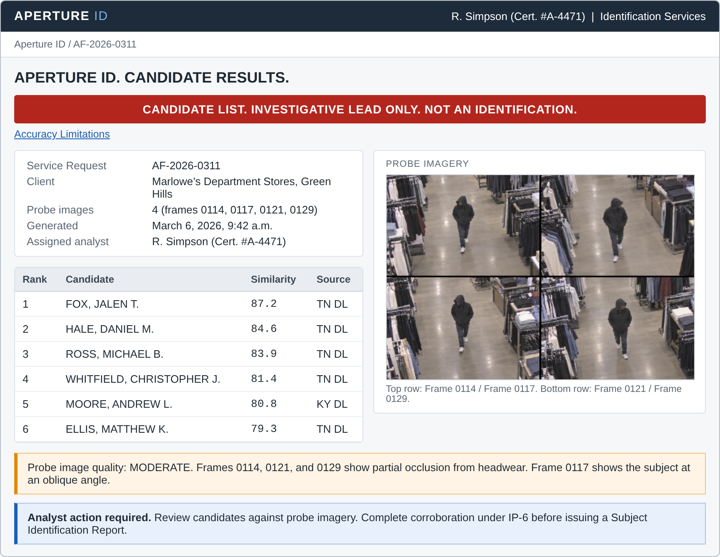
DEPOSITION EXHIBIT 2
Simpson 9/15/26
Accuracy Limitations page
Internal page accessible from the candidate list screen. Produced by Aperture in discovery.
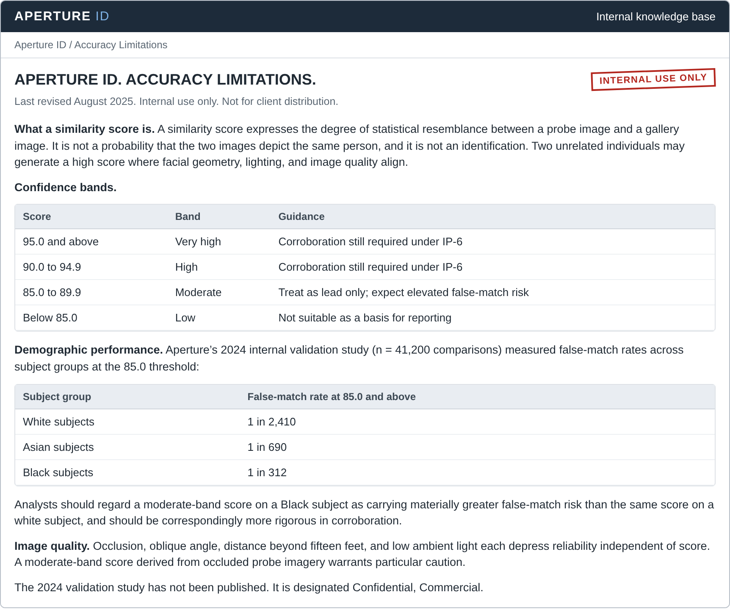
DEPOSITION EXHIBIT 3
Simpson 9/15/26
Identification Protocol IP-6
APERTURE FORENSICS, INC.
IDENTIFICATION PROTOCOL IP-6. CORROBORATION REQUIREMENT
Adopted September 2024.
6.1. Purpose. A candidate match is a statistical result. It becomes an identification only when an analyst has independently satisfied himself of the subject’s identity. This protocol states the minimum corroboration required before an identification may issue.
6.2. Requirement. No candidate shall be named in a Subject Identification Report unless the analyst has obtained corroboration by at least two means not derived from the algorithmic comparison. Qualifying means include:
1. An eyewitness who knows the subject by sight and identifies him without suggestion;
2. Transaction, loyalty, or membership records placing the subject at the location;
3. Vehicle or license plate information;
4. Recovered physical evidence linking the subject to the incident;
5. Documented prior contact between the subject and the client location.

6.3. Documentation. The Subject Identification Report shall state each means of corroboration obtained.
DEPOSITION EXHIBIT 4
Simpson 9/15/26
Subject Identification Report AF-2026-0311
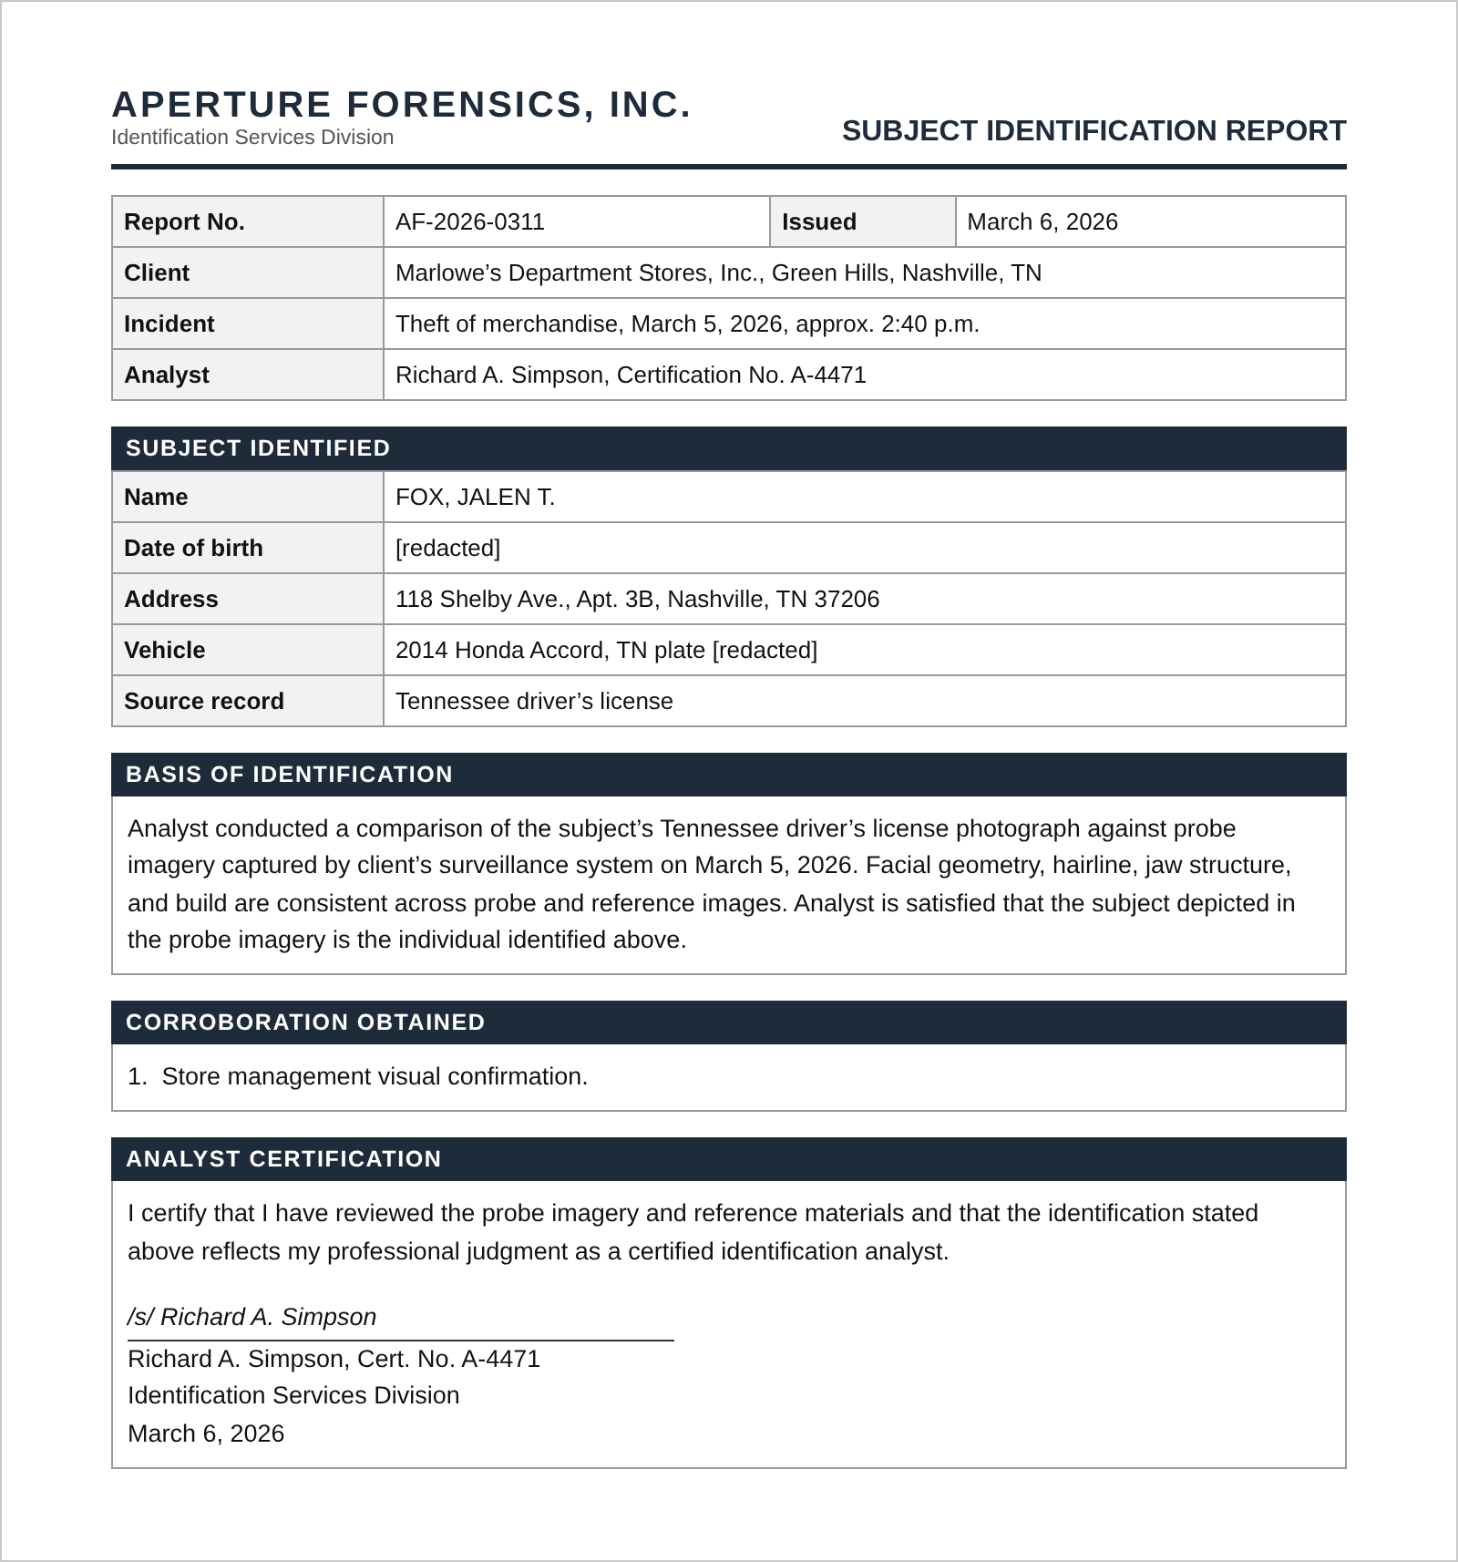

DEPOSITION EXHIBIT 5
Simpson 9/15/26
Aperture internal emails
Produced by Aperture in discovery, in chronological order.
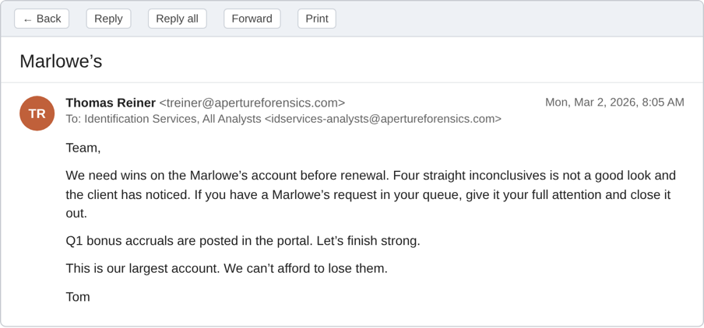
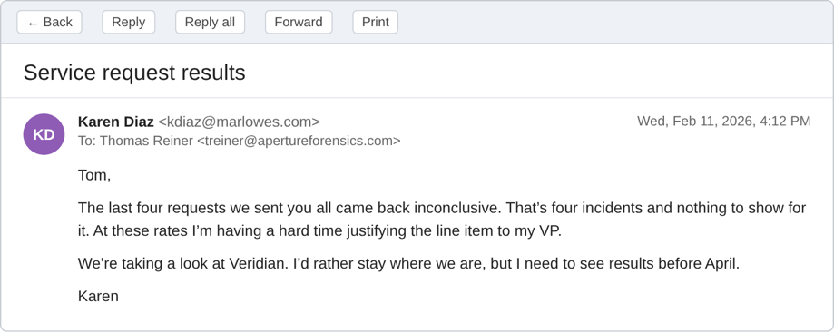

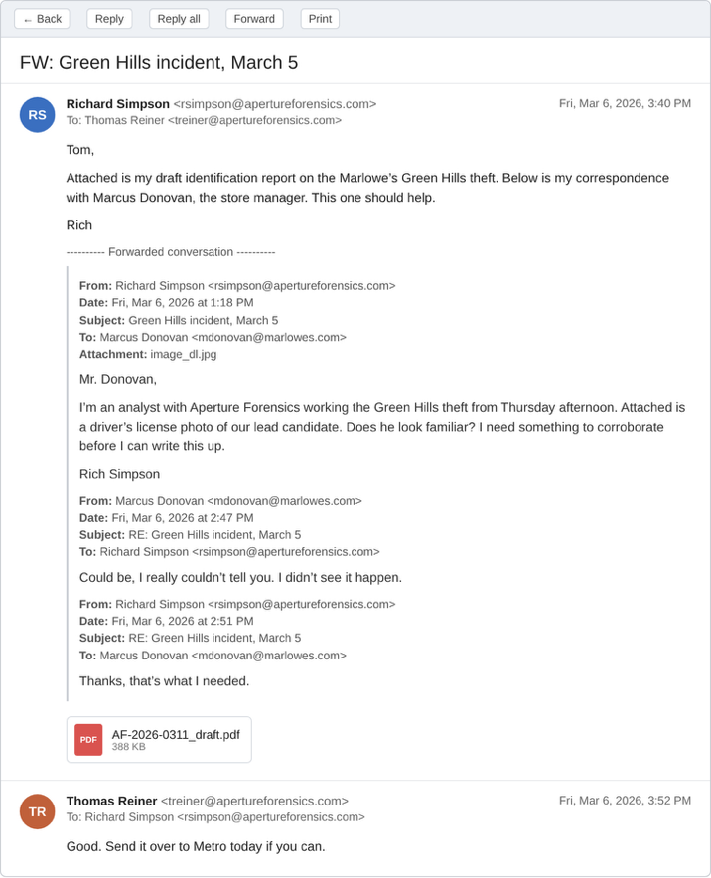
DEPOSITION OF DETECTIVE OWEN BLAIR (EXCERPTS)
Fox v. Aperture Forensics, Inc. (M.D. Tenn.) · Taken September 24, 2026
Q. Tell me about the Marlowe’s call on March 5.
A. Routine retail theft. I went out, talked to Donovan, got the stills off their system. Nobody saw the guy leave and there was nothing else to work with. Those usually go nowhere.
Q. How would you describe the quality of the still images?
A. Not great. It’s a ceiling camera and he’s twenty feet away with a hoodie on. You can see a face but it’s not a portrait.
Q. Had you worked with Aperture before?
A. Fourteen cases, something like that. Over maybe three years I never had a problem.
Q. Any of those turn out to be the wrong person?
A. Not that I know of. Nobody ever called me to say so.
Q. Let’s talk about the call on March 6. How long was it?
A. Short. My phone log shows six minutes.
Q. Who called whom?
A. He called me.
Q. What did he say?
A. What’s in my notes. Aperture had made a positive identification, it was Jalen Fox, the store manager had confirmed it, and I shouldn’t need to go further on it. He gave me the name, the date of birth, the address, and the car.
Q. When Simpson said you “shouldn’t need to go further,” what did you think he meant?
A. I thought that meant that he had investigated the lead, confirmed it, and that it was something I could rely on to move forward with an arrest.
Q. Did he say the identification came from facial recognition software?
A. Not that I recall, no.
Q. Would you have written that down?
A. I’d like to think so. It’s not in my notes.
Q. Mr. Simpson says he told you it came through their system. Does that sound familiar?
A. He may have said something like that. I couldn’t tell you one way or the other. If he did, I didn’t take it to mean a computer made the call.
Q. What did you understand “positive identification” to mean?
A. That somebody had looked at it and was sure. That’s what the words mean to me.
Q. Had you heard the term “candidate list” before?
A. No.
Q. Did you know their system produces a numerical score?
A. No. Nobody ever mentioned a score to me, not on this one or any of the others.
Q. Did you ask Mr. Simpson any questions during the call?
A. I don’t think I did. He had it wrapped up. That was the impression I got.
Q. Did Mr. Simpson send you anything?
A. Yes. After the call he sent me his signed identification report.
Q. What did the report say?
A. That the analyst compared the license photo to the stills and that store management confirmed it.
Q. Did it mention facial recognition software or a score?
A. No.
Q. What did you do after the call?
A. Pulled Fox’s license photo and compared it to the stills myself. I thought it was the same guy. Same build, jaw lined up, hairline looked right.
Q. How long did that take?
A. A few minutes.
Q. Did you view the underlying surveillance video?
A. No. I had the four stills. That’s what I worked from.
Q. Did you speak with Mr. Donovan?
A. No. I was told the store manager had confirmed it.
Q. Did you run Mr. Fox for a criminal record?
A. I did. He didn’t have one.
Q. Did that give you pause?
A. Not really. Plenty of people have a first offense.
Q. Did you check whether Mr. Fox had ever been in that store?
A. No. That didn’t occur to me, and I wouldn’t have had a way to do it without asking the store.
Q. Would you have arrested Mr. Fox based on your photo comparison alone?
A. No. Two men can look alike. What I had was Aperture saying it was him and the store manager saying it was him. The photos were consistent with that. I wouldn’t have moved on the photos by themselves.
Q. When did you swear the affidavit of complaint?
A. That evening, after the call. I went to the courthouse and swore it out, and I attached Mr. Simpson’s report.
Q. Who made the decision to arrest that night?
A. I did. I put out the description and patrol picked him up.
(Deposition Exhibit 6 was marked for identification.)
Q. I’m handing you Deposition Exhibit 7. Do you recognize it?
A. Yes. That’s the order dismissing the charge against Mr. Fox.
Q. Is that the final disposition of the criminal case?
A. Yes. Dismissed with prejudice.
Q. Anything else you think we should know?
A. Only that I took him at his word. He’s a certified analyst, he said positive identification, and he said the store manager backed it. I don’t know what else I was supposed to do with that.
DEPOSITION EXHIBIT 6
Blair 9/24/26
Order of Dismissal
